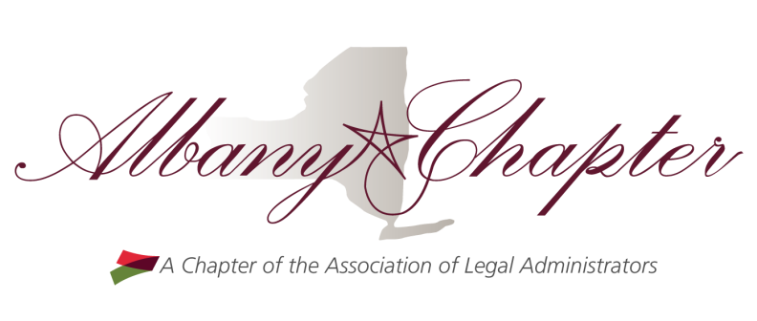
Chapter Update – Quarter 2

Well everyone we’re halfway through our term year and I couldn’t be more excited about the progress we’ve made in the first half of this year. We also have a lot to look forward to in the second half of this term including great speakers at our upcoming luncheons, our Community Challenge in October, the Business Partner Expo in November, and our “always-a-good-time” holiday luncheon and gift exchange in December! Read on for more information about all that your Board is working on.

October
October is the month of ALA’s Community Challenge. This year we will again be supporting the South End Children’s Café by volunteering to cook dinner for families and children at the Café. There are still available time slots in October so if you’re interested in volunteering please contact Sarah at admin@psgglaw.com. To increase participation, we are securing several dates to volunteer so check your calendar and be sure to sign up!

November
Richard has been hard at work coordinating our Business Partner Expo scheduled for November 8 from 5-7:30 at a new venue the Cornerstone at the Plaza. As always there will be plenty of drinks and appetizers catered by Mazzone Hospitality, a great view overlooking the Capital, and most importantly our Business Partners will be there to showcase their products and services. It’s a great way to learn more about out BP’s and what they offer in a hands-on environment. Be sure to stop by the eBizDocs table and introduce yourself to our newest BP. Your attendance is important to the success of our chapter and you surely won’t want to miss this event so please contact Richard at richard.lauricella@srclawoffices.com to register today!

Also in November is our Lunch & Learn on Communicating Clearly and Concisely presented by Dale Carnegie of North East New York. Dale Carnegie is a trusted source on communication and human relations. This session is sure to be valuable and informative so please contact Sue at Weidman@woh.com to register for the luncheon scheduled for November 15.

December
December brings our enjoyable holiday party scheduled for the 6th at Yono’s in Albany. Unlike our other luncheons this month we like to kick back and relax over a delightful meal to close out the 2018 calendar year followed by an exciting gift exchange. More details will be announced in the coming weeks.

A reminder that the annual salary survey was completed, and the results are now available. Many thanks to Tom Donovan and Danna Töews-Letourneau at Marvin & Co. for their assistance with the survey again this year. A reminder that if you participated in the survey you are entitled to a free copy of the final report. Please contact Danna to pick it up. Copies are also available for purchase; contact Danna if you’d like to purchase a copy.

Updates from the National Association of Legal Administrators
As a reminder there are many valuable tools and resources available to all of you as members of the National Association. A few of them are listed below for your convenience.

ALA’s Legal Marketplace can be found at http://legalmarketplace.alanet.org/

ALA’s Career Center can be found at https://www.alanet.org/career-center/job-bank-overview

ALA Online Communities can be found at http://community.alanet.org/

ALA Business Partner Listserv is available to subscribers and can be found at:
https://www.alanet.org/membership/chapters/chapter-leader-resources/chapter-business-partner-relations-resources/ala-bp-listserv

ALA member savings in the VIP program at https://www.alanet.org/marketing-opportunities/ala-vip-overview

ALA’s brand-new Job Description toolkit is now available at no cost for ALA members! It’s specifically designed to assist YOU in in drafting job descriptions using the ALA Uniform Process Based Management System (UPBMS) taxonomy classification/ codes. You can find it here:
https://my.alanet.org/ItemDetail?iProductCode=JOBDESCTOOLKIT&Category=JOBTOOLKIT

Professional associations such as the Association of Legal Administrators are well recognized as valuable tools of American business but are subject to severe scrutiny by both federal and state governments. It is imperative that every professional association member refrain from indulging in any activity which may be the basis of a federal or state antitrust action. You should familiarize yourself with ALA's Antitrust Guide which can be found here.
https://www.alanet.org/…/governance-do…/antitrust-guide.pdf…

Additionally, you can find a copy of ALA’s Code of Professional Responsibility and Code of Ethics on our website. Please take a few minutes to read these over and refresh yourself on these policies.

ALA’s Strategic Plan Update for Quarter 3 includes 5 goals: Define Identity, Increase Member and Business Partner Value, Enhance Thought Leadership, Advance Legal Management Professional Development, and Build Community and Engagement. I encourage all our Albany Chapter members to think of ways we can grow our own chapter using these initiatives. More information on ALA’s Quarter 3 Strategic Plan can be found here:
https://www.alanet.org/about/about-ala/ala-strategic-plan/strategic-plan-update-q3---2018

Mission Statement
ALA is the undisputed leader for the business of law, focused on the delivery of cutting-edge management and leadership products and services to the global legal community.
We identify and provide solutions to the most strategic and operational challenges our members and customers face today, while we prepare them for the opportunities and challenges of tomorrow.

